**Samuel Okwalinga – Cat6**

|  |  |
| --- | --- |
| **TERM** | **DESCRIPTION** |
| Open source | Open-source software is a type of computer software in which source code is released under a license in which the copyright holder grants users the rights to use, study, change, and distribute the software to anyone and for any purpose. Open-source software may be developed in a collaborative public manner |
| Run-time environment | A configuration of hardware and software. It includes the CPU type, operating system and any runtime engines or system software required by a particular category of applications. It primarily implements portions of an execution model. |
| Cross-platform | Cross-platform software is computer software that is implemented on multiple computing platforms/ operating systems. |
| API | An application programming interface is a computing interface which defines interactions between multiple software intermediaries. It defines the kinds of calls or requests that can be made, how to make them, the data formats that should be used, the conventions to follow, etc |
| V8 Engine | V8 is an open-source JavaScript engine developed by The Chromium Project for Google Chrome and Chromium web browsers. |
| Single-thread | single threaded processes contain the execution of instructions in a single sequence |
| NPM | Npm(Node Package Manager) is a package manager for the JavaScript programming language |
| Package | A package is a single container that contains one or more items that help make up the overall package. For example, a processor package is the overall computer processor, which contains all the necessary parts that allow it to work in your computer. |
| Library | A library is a collection of non-volatile resources used by computer programs, often for software development. These may include configuration data, documentation, help data, message templates, pre-written code and subroutines, classes, values or type specifications. |
| Framework | A framework generally provides some base functionality which you can use and extend to make more complex applications. |
| Modular programming | Modular programming is a software design technique that emphasizes separating the functionality of a program into independent, interchangeable modules, such that each contains everything necessary to execute only one aspect of the desired functionality. |
| Database | Databases are computer structures that save, organize, protect, and deliver data. CRUD operations can be performed on databases. Two categories exist – Relational and Non-relational database. |
| Package.json | A package. json is a JSON file that exists at the root of a Javascript/Node project. It holds metadata relevant to the project and it is used for managing the project's dependencies, scripts, version and a whole lot more. |

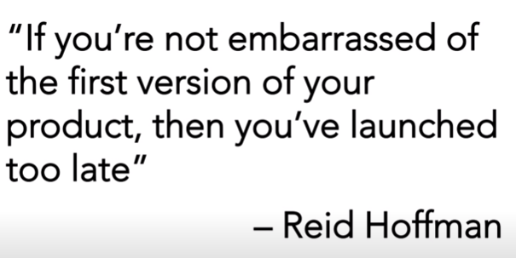

Successful people find a way to start even before they are ready.

